

# 

COMPLAINT : 34

DATE: 13/Mar/2021

The Manager,

BANK AL-HABIB

MALKWAL,LHR ZONE

Subject: Quotation of Repair and Maintenance. FOR APPROVAL

Number of AC: 1

|  |  |  |  |  |
| --- | --- | --- | --- | --- |
| Sr. | Job Description | Qty | Rate | Amount |
|  | Gas Charging ( upto to 2 Ton) Inverter AC Unit Unit | 1 | 4670.0 | 4670.0 |
|  | Copper | 1rft | 22.333 | 22.333 |
|  | Total |  |  | 4692.333 |
|  | Tax 16% |  |  | 750.77328 |
|  | Conveynce Charges | 2 | 800 | 1600 |
|  | Total |  |  | 7043.10628 |

**Yours truly,**

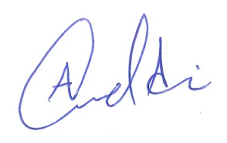 **ECO ENTERPRISES**